**# Create Database**

**Create Database Swiggy;**

**# Set the Databse to work on**

**Use Swiggy;**

**# Show All Record of Table**

**SELECT * FROM tbl_swiggy;**

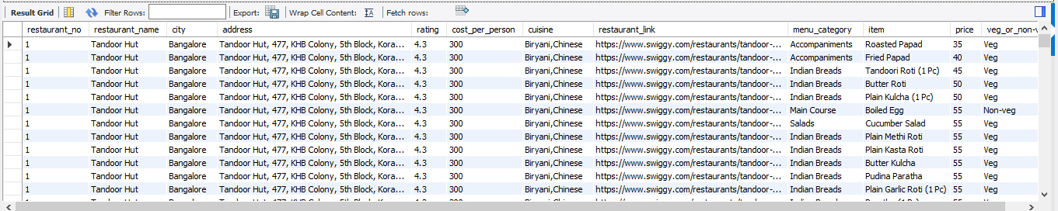

**# Show All Record of Table**

**SELECT Count(*) Total_Data FROM tbl_swiggy;**

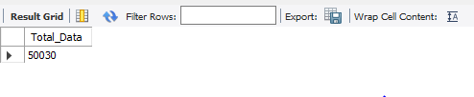

**# What is the most 2 common Cuisine Among the Restaurant in Dataset?**

**Select Count(*) as Total_Count, cuisine**

**from tbl_Swiggy**

**Group by cuisine Order By Total_Count Desc Limit 2;**

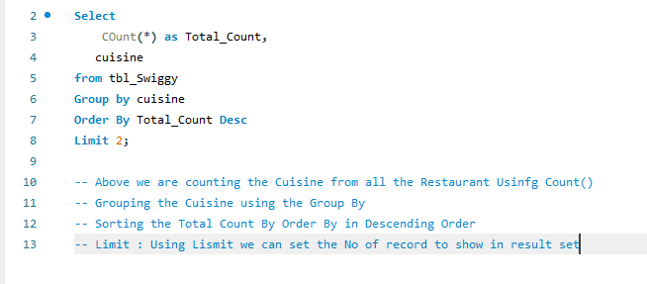

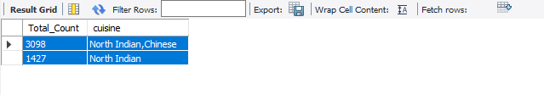

**# How many restaurant has rating greater than 4.5**

**select Count(distinct Restaurant_Name ) As Rating_Count**

**from tbl_swiggy**

**where rating > 4.5;**

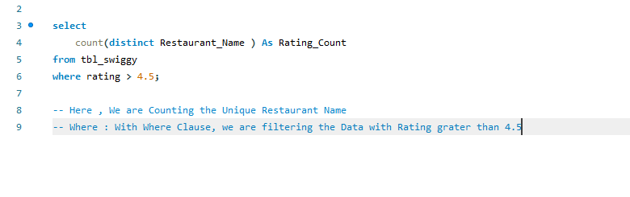

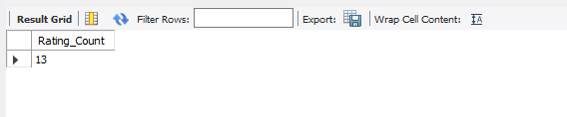

**# Which is the top 1 City with Highest No of Restaurants ?**

**Select Count(distinct Restaurant_Name) Total, City**

**from tbl_swiggy**

**Group by City Order by Total Desc Limit 1;**

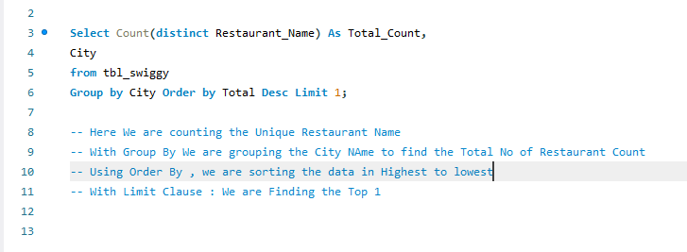

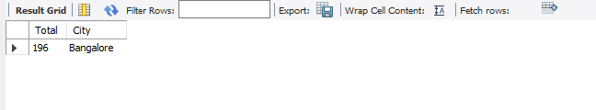

**# How many Restaurant Have the word "PIZZA" in their name ?**

**Select Distinct Restaurant_Name from tbl_swiggy**

**where Restaurant_Name like '%Pizza%';**

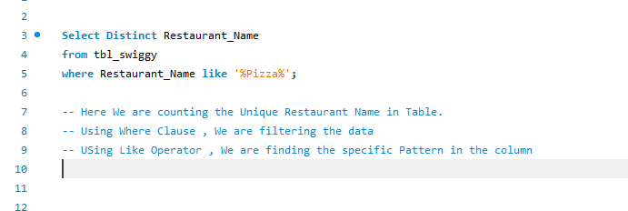

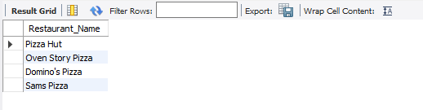

**# What is the average rating of restaurant in each city?**

**Select City, avg(rating) As Avg_Rating**

**From tbl_Swiggy Group By City, Order by Avg_Rating DESC;**

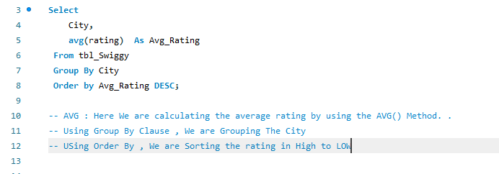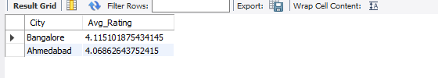

**# What is the Highest Price of Item Under the ‘Recommended’ Menu category for each Restaurant?**

**Select distinct Restaurant_Name, Menu_Category, Max(Price) As Highest_Price from tbl_Swiggy**

**Where Menu_Category = 'Recommended'**

**Group By Restaurant_Name, Menu_Category ;**

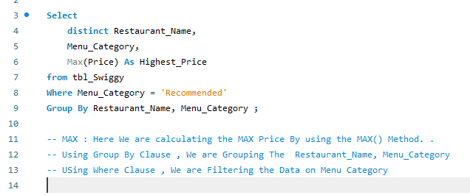

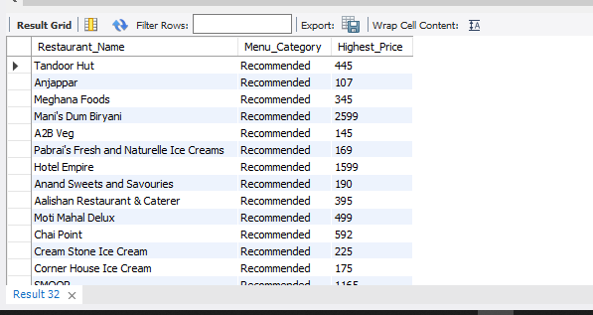

**# Find the Top 5 Most Expensive Restaurants that offers Cuisine other than North India Cuisine?**

**Select**

**Distinct restaurant_name, cost_per_person**

**from tbl_Swiggy**

**where cuisine != 'North Indian'**

**Order By cost_per_person**

**DESC Limit 5;**

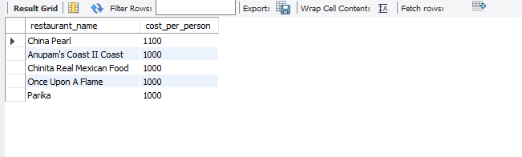

**# Find the Restaurant that Have an Average cost higher than the Total Average cost of all Restaurants Together ?**

**Select**

**Distinct restaurant_name, cost_per_person**

**from tbl_Swiggy**

**where cost_per_person > (**

**Select avg(cost_per_person) from tbl_Swiggy**

**);**

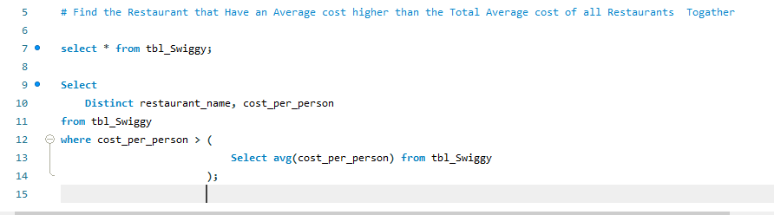

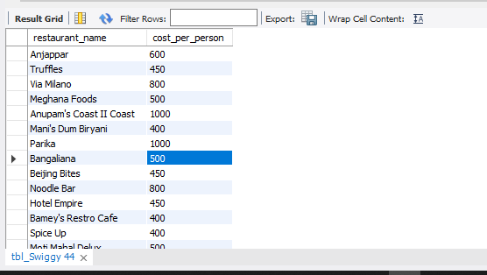

**# Retrieve detail of All restaurants that have the Same Name but located in Different cities ?**

**select t1.restaurant_name, t1.city, t2.city**

**from tbl_swiggy t1 inner Join tbl_swiggy t2**

**on t1.restaurant_name = t2.restaurant_name**

**and t1.City <> t2.City;**

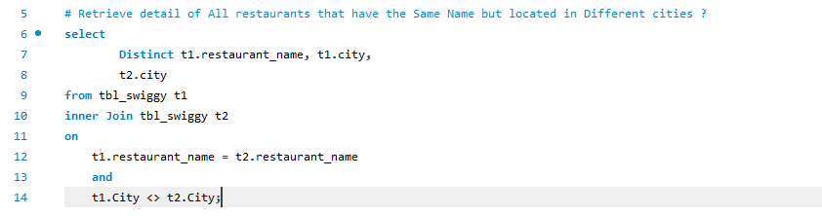

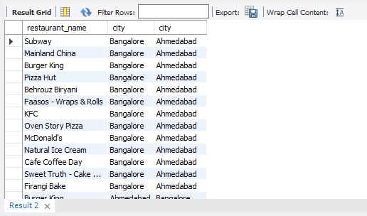

**# which restaurants offers the Most No of Item In the 'Main Course' category**

**Select**

**Distinct restaurant_name, Count(Item) As Total_Item_Count**

**from tbl_Swiggy**

**where menu_category = 'Main Course'**

**group By restaurant_name**

**Order By Total_Item_Count DESC;**

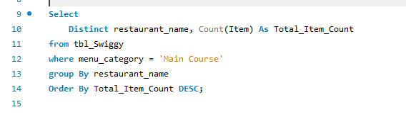

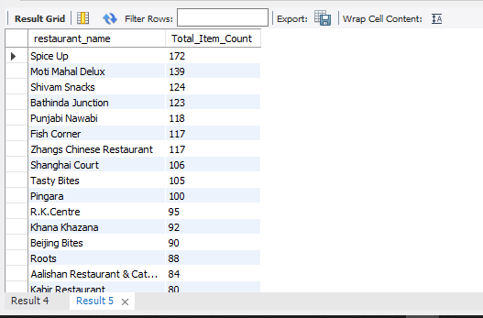

**# List The Restaurant providing the Lowest Average price for all Item?**

**Select Distinct Restaurant_Name, Avg(Price) as Avg_Price from tbl_Swiggy**

**group by Restaurant_Name**

**Order By Avg_Price ASC ;**

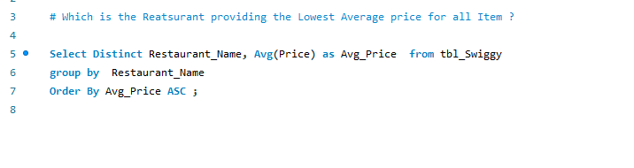

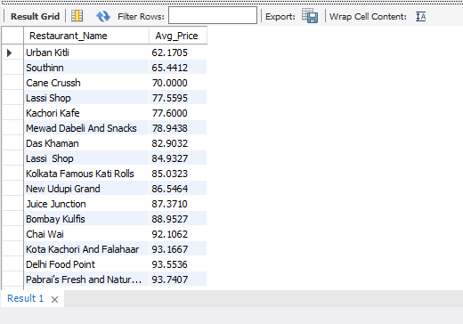

**# Which is the Top 5 Restaurant providing Number of Category?**

**Select Distinct Restaurant_Name,**

**count(Distinct Menu_Category) as Catefory_Count**

**from tbl_Swiggy**

**group by Restaurant_Name**

**Order By Catefory_Count Desc**

**Limit 5 ;**

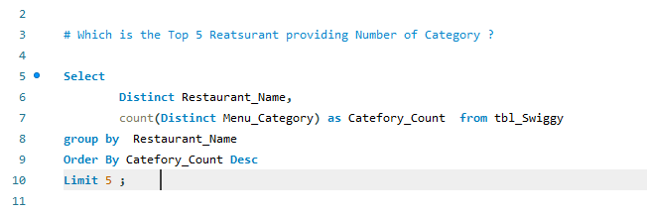

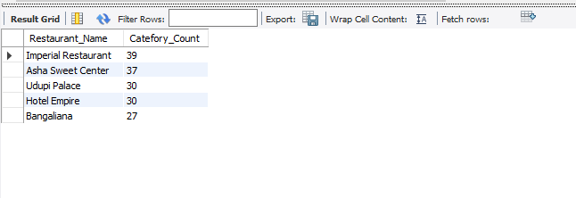

**# List The all Menu Category**

**Select Distinct Menu_Category From tbl_swiggy ;**

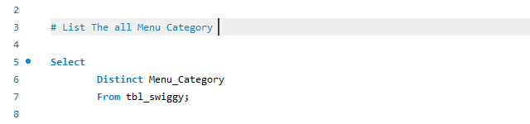

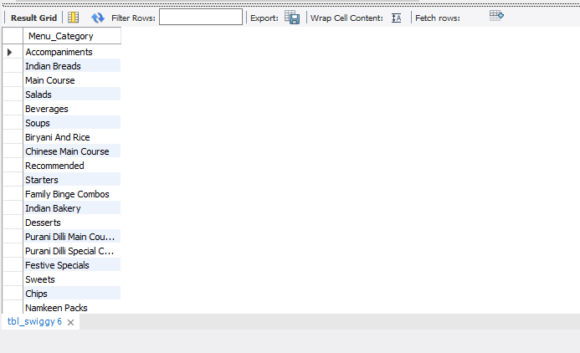

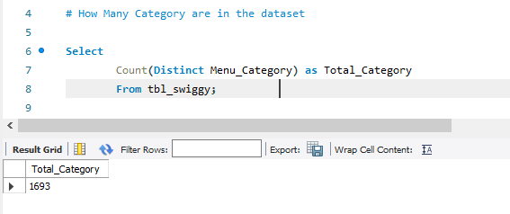

**# Show Category Wise Total Item ?**

**Select Distinct Menu_Category, Count(Distinct Item) as Total_Item**

**From tbl_swiggy**

**Group by Menu_Category**

**Order By Total_Item Desc ;**

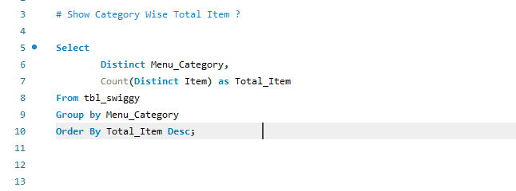

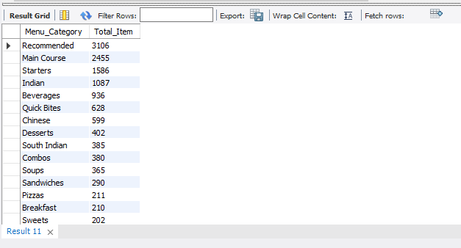

Follow Me : https://www.linkedin.com/in/vivekvishwas/